Brightspeed EASE
VFO Overview

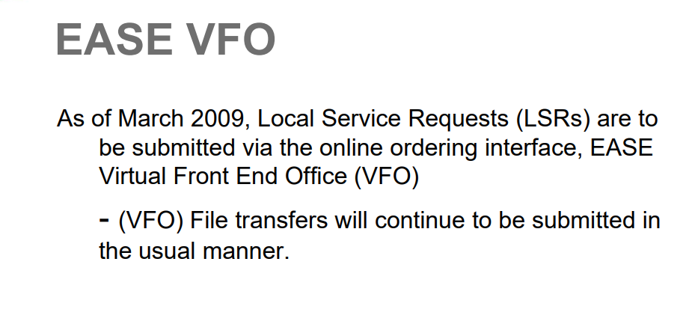

EASE VFO Login Screen

After accessing EASE, enter your user name and password and select Local from the module dropdown.

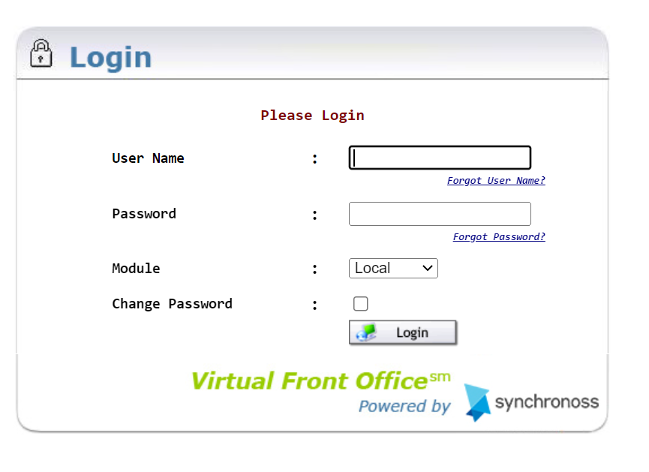

EASE VFO Order List
After successfully logging in - the Order List Displays.

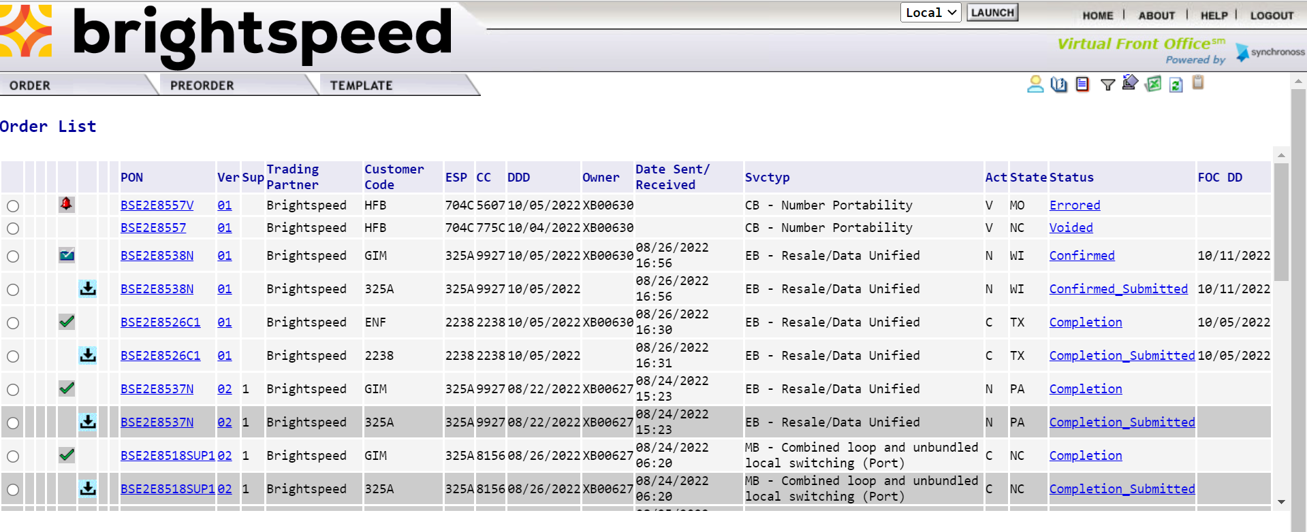

Order List Status ICON

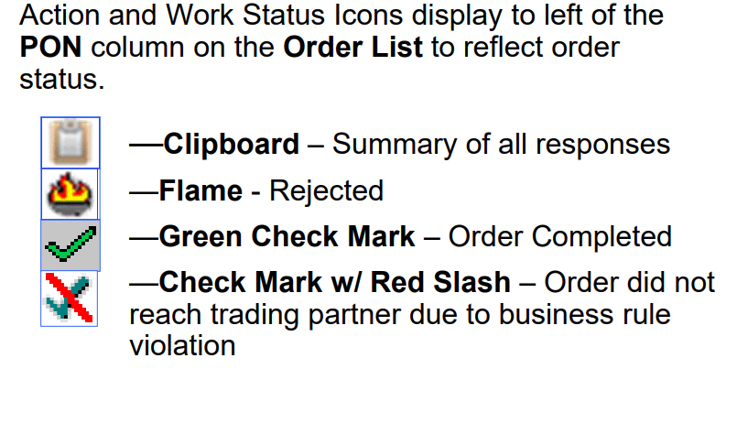
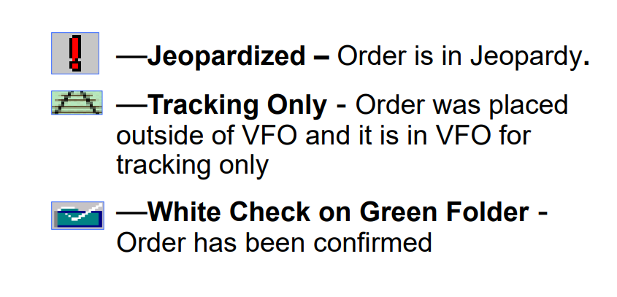
Order List Function ICONs

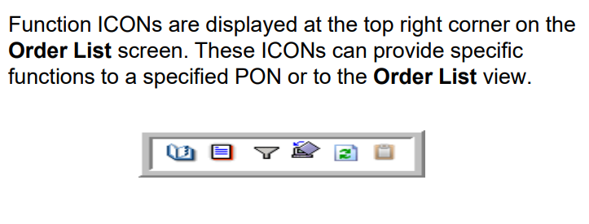

Order History Function ICON

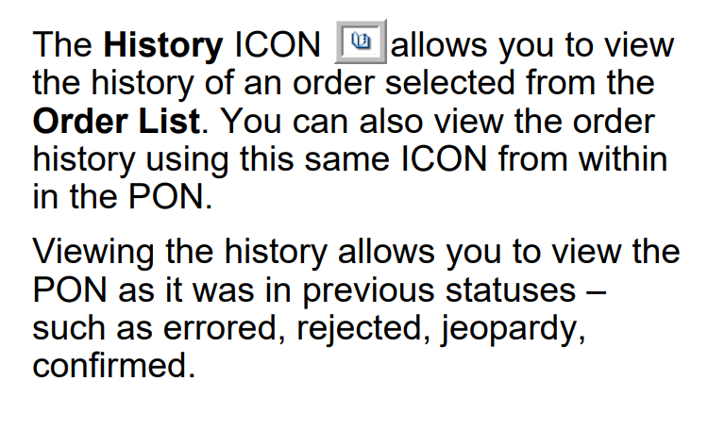

Order List Status and Function ICONs

Mark the radio button next to the PON desired and select the History function ICON to view the history of the PON.

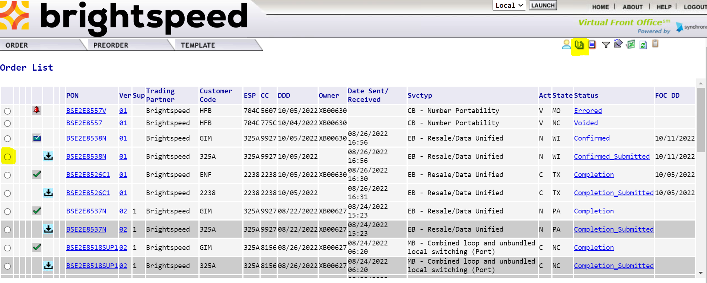

Order History Screen
Click on the desired status link to view the PON or the PON Response. For example clicking on Confirmed status allows you to view the Confirmation Response.

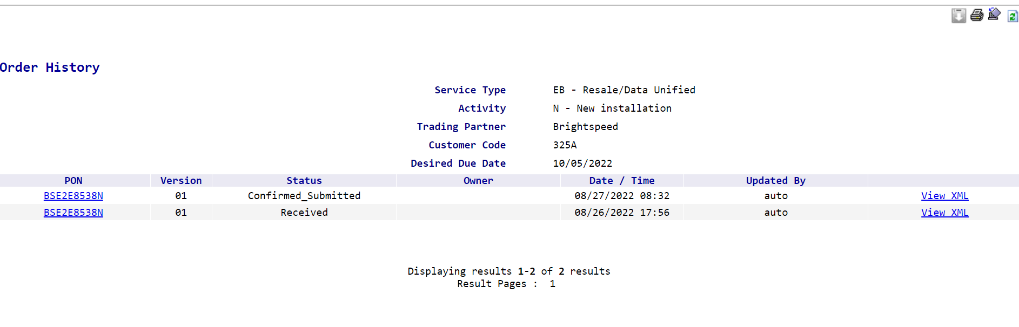

Order Filter Function ICON

The Filter ICON allows you to search for specific types of orders based on criteria entered on the Order List Filter screen—for example, you could search for orders based on statuses such as Errored, Rejections, Jeopardy and Completions.

Order List Filter Screen

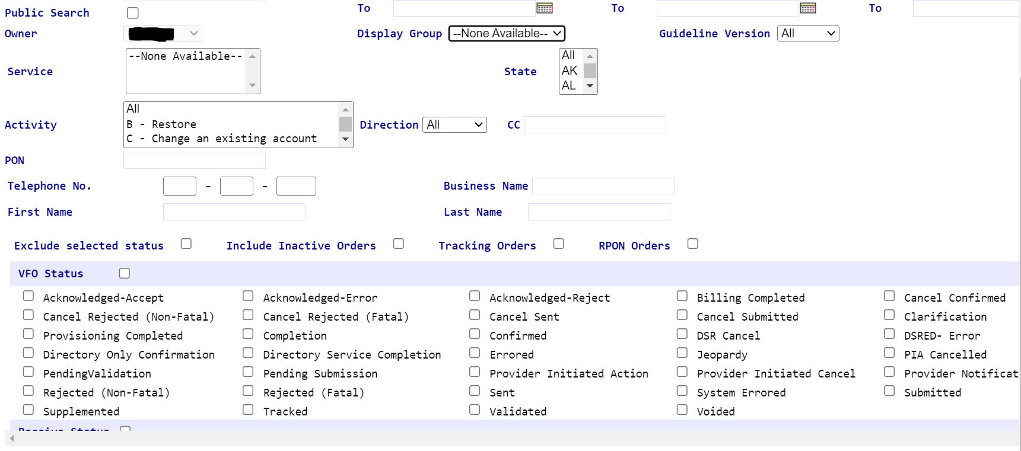

Searching for an Order
To search for an existing order in EASE VFO, select Search from the Order tab menu.

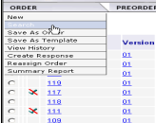

Order Search Page

PON is the default search option, but you can select other search options from the drop down and type your search criteria in the Search For box.

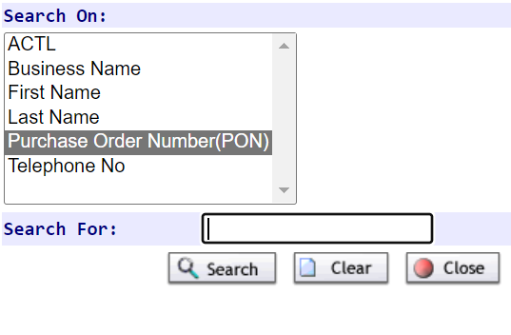

Viewing a PON

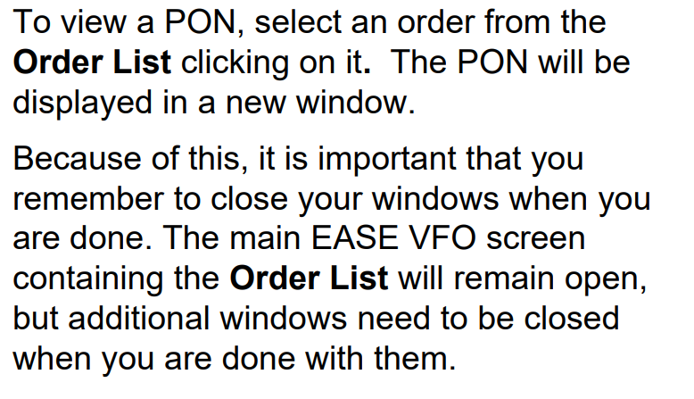

Viewing a PON (Continued)
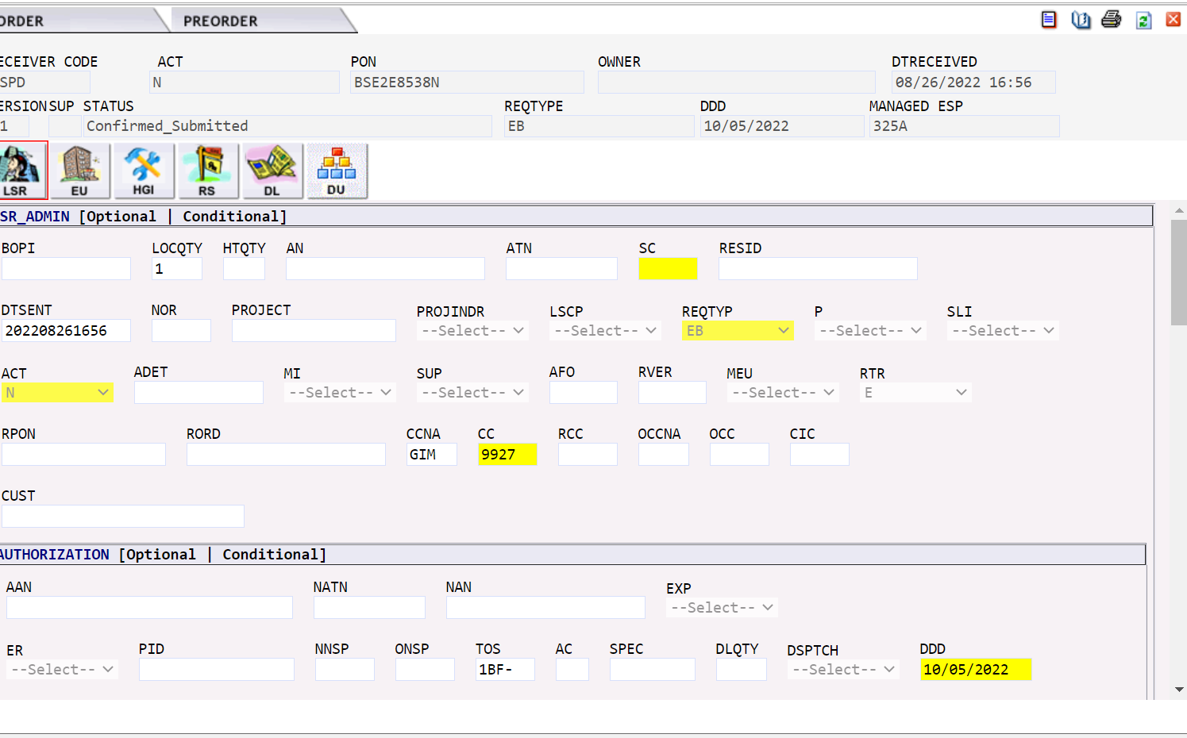

Order Initiation Window
Once New is selected, the Ordering Initiation window appears.

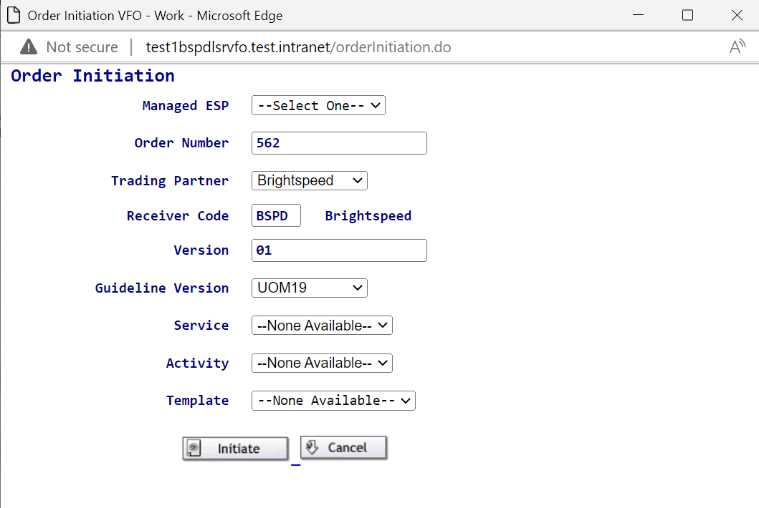

VFO Order
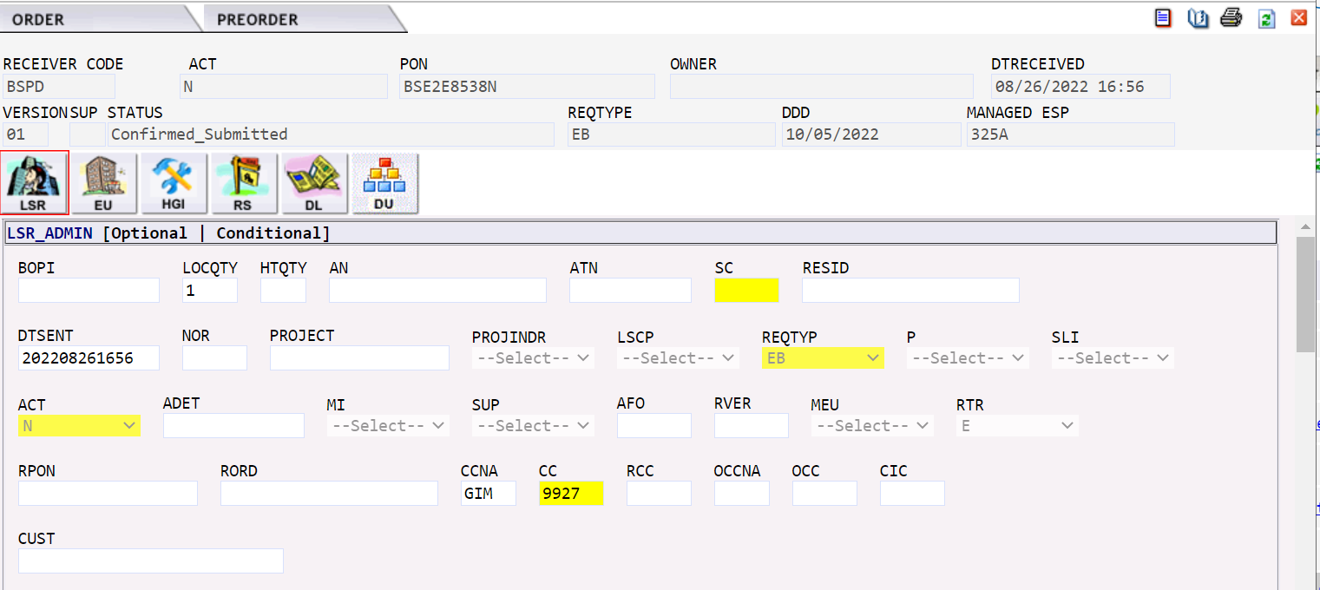

Order ICON Functions

Once an order is generated there are specific functions that may be able to be performed with the order. The ICONs in the upper right hand corner of the order perform specific functions.

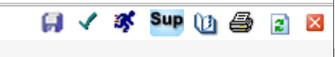

Validate Function

Validate ICON

This ICON is used prior to order submission to initiate an error check. Validate is also available from the Order tab menu.
- If the order is not in a status that allows a validation check, you will get a pop-up box with an error
- If order validation is successful, you will not get a pop-up box containing errors within the order

Order Errors
Once the order is validated, you may or may not receive an ErrorCode List box.

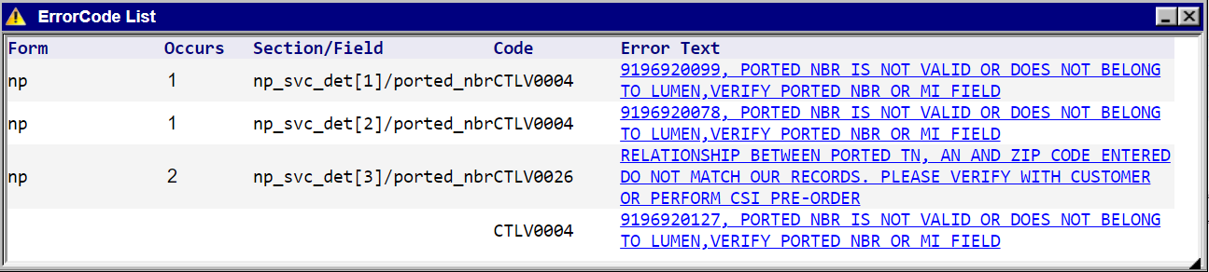

Submit Function
Submit ICON
This ICON is used to submit the order to Brightspeed once all errors are cleared.
The Status field within the PON should change to Submitted—then systematically change to Sent Sent once the PON is accepted by the system.

Supplement Function

Supplement ICON

These ICONs are used to SUP an existing order. You can SUP an existing order once it has been accepted by Lumen all the way up until it is completed. Be sure to use the SUP number that reflects your request.

1 = Supplement - Cancel
2 = Supplement - DDD Change
3 = Supplement - Other post-FOC
4 = Supplement - Correction pre-FOC

Order Tab Within an Order

The Order tab in the upper left hand corner of your order contains a drop-down menu.

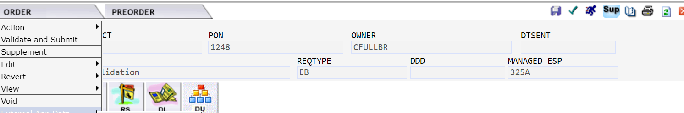

Order Tab Menu Options
Action
- Save Order – Saves changes made to the order
- Save As Order – Allows you to replicate an existing order. Can not modify Req type
- Save As Template – Allows you to save an existing order as a template. When you get ready to use the template, you select it on the Order Initiation page
- Validate – Performs the same function as the green check ICON on the top right - sends the order through the validation process

Order Tab Menu Options (Continued)

Validate and Submit – Performs error check and submits when all errors cleared.
Edit
- Create Response – Used internally to send FOC’s, Rejects, Completion etc notifications to the customer
- Apply Template – Allows use of existing templates for the order
- Resubmit Original Order – Allows the user to resubmit order if order to not change to Sent status

Order Tab Menu Options (Continued)

Supplement
- Cancel Order
- DDD Change
- Other
Revert
- Revert to Last Saved – Reverts the order to the last time you saved it
- Revert to Last Submit – Reverts the order to the last time you submitted it

Order Tab Menu Options (Continued)

View
- View History – Shows you the history of the order
- View Error List – Shows you errors associated with the order
- View PrintableVersion - Puts the order into a printable format
- Refresh – Refreshes the order

Void
- Voids an order that has not been submitted

Order Tab Menu Options (Continued)
External App Data Menu displays the options based on order type.

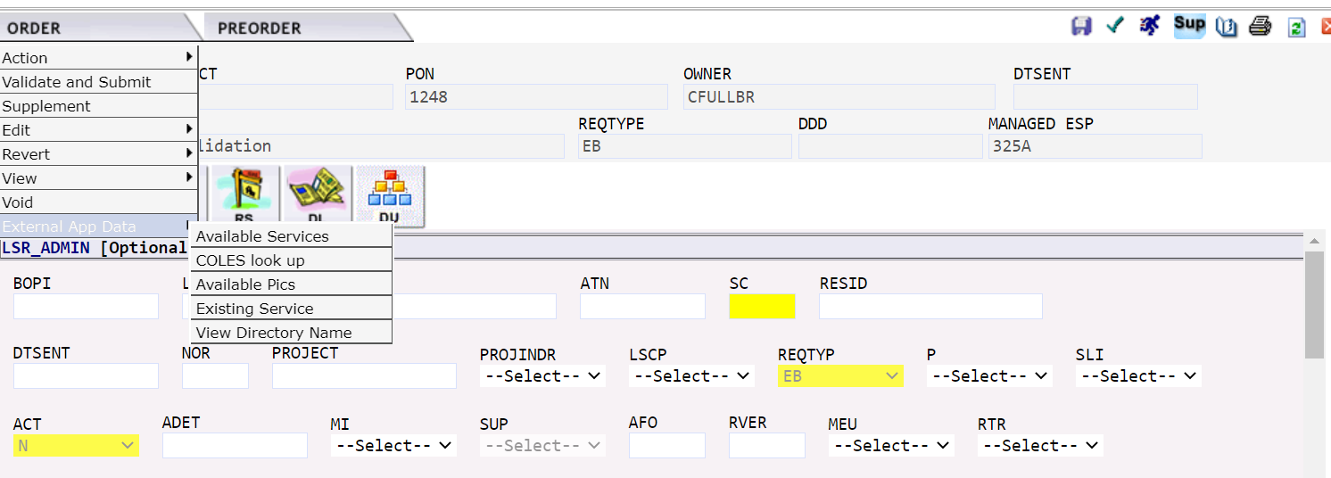

PreOrder in EASE VFO

Preorder tab is available in EASE VFO which allows the user to:

- View Customer Service (CSI) records of existing Brightspeed working telephone numbers and your end-user customers
- Perform an address validation
- View directory listings belonging to Brightspeed or the CLEC’s company

PreOrder Tab
Below is an example of the Preorder tab in EASE VFO.

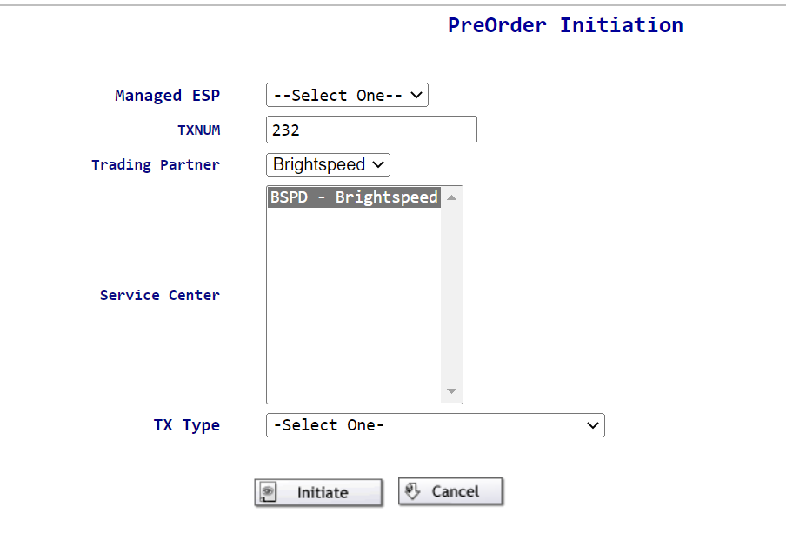

Order Tab Menu Options (Continued)

Available Services – based on contracts and services available in the area

- Telephone Number – allows the user to assign new telephone numbers
- Centrex Feature Code – displays Centrex code information
- Available PICS – displays long distance carriers available in the area
- Existing Services – displays existing services on a Brightspeed working telephone number (WTN) if a CSI preorder took place on the Preorder tab

EASE Highlights

- Brightspeed will be conforming closely to LSOG 10 standards. This means requiring stricter adherence to data requirements prior to order acceptance
- The policies governing error handling will be modified for increased order accuracy

EASE Hightlights (Continued)

- Preorder data can not be transferred to the LSR.
- Directory listing information will no longer be entered into eSUDS
- The listing information will be entered on the DL page of the EASE LSR
- EASE will validate the data for the correct syntax and format and send the information to the Directory Listing database

EASE Hightlights (Continued)

Telephone Number Assignment
- Customers choosing to select their own telephone numbers in TNA must complete the LSR within 2 hours
- If the telephone number is systematically selected, it is business as usual

EASE Hightlights (Continued)

- External customers will have the ability to manage their own EASE User ID and passwords. The process will be distributed 30 days prior to implementation
- The Customer notification process remains the same via the Application Performance Team

